TenantExitEase: Cloud-Based Move-Out

Checklist and Rental Property Exit

Tracker

**Submitted By** – Yash Raj Anand

**Project Description**

TenantExitEase is a cloud-based web platform designed to simplify the tenant move-out process and ensure transparent communication between tenants, landlords, and administrators. Built using FastAPI for the backend and HTML/CSS/JavaScript for the frontend, the system leverages AWS services like EC2 for hosting, DynamoDB for storing structured exit and damage data, S3 for file/document uploads, and SES for email notifications.

The platform offers role-based dashboards: tenants can submit digital exit requests and damage reports with file attachments; landlords can view approved exits and submit damage claims with auto-calculated costs; and admins can monitor all activities, update request statuses, and ensure workflow integrity.

With its real-time tracking, document handling, and streamlined status updates, TenantExitEase modernizes traditional property handovers. It minimizes disputes, eliminates paper forms, and improves accountability in rental property management. IAM-based access control ensures that all operations are securely managed according to user roles.

**Scenario**

**Scenario 1: Smooth Tenant Exit Submission**

A tenant, Riya Das, plans to vacate her apartment by the end of the month. She logs into the TenantExitEase portal, fills out the exit form with her reason, selects the move-out checklist items (e.g., Room Cleaned, Keys Returned), and uploads a supporting document as proof. After submission, she receives a confirmation and can track the status of her request in real-time. This digitized process helps her avoid long email chains or manual paperwork and ensures that her exit process is documented and traceable by both the landlord and admin.

**Scenario 2: Landlord Files a Damage Report**

After a tenant vacates the premises, the landlord inspects the room and finds damage to a fan and a chair. Through the Landlord Dashboard, they access the damage report form, select the damaged items, enter a short description, and the system auto-calculates the estimated cost. The report is submitted and becomes visible to both the tenant and the admin. This scenario showcases how the platform eliminates verbal disputes and formalizes the damage claim process with visual documentation and cost transparency.

**Scenario 3: Admin Resolves Multiple Requests**

The admin logs into their dashboard to view all incoming tenant exit requests and landlord damage reports. They notice one request marked "Pending" with no supporting documents, and another flagged as “InReview.” The admin updates the status of the reviewed request to “Approved” and requests clarification on the other. Using the platform’s centralized table views and real-time updates, the admin efficiently moderates all interactions. This scenario highlights how TenantExitEase empowers administrators to track, validate, and manage rental exit workflows without manual coordination or paperwork.

**AWS Architecture**

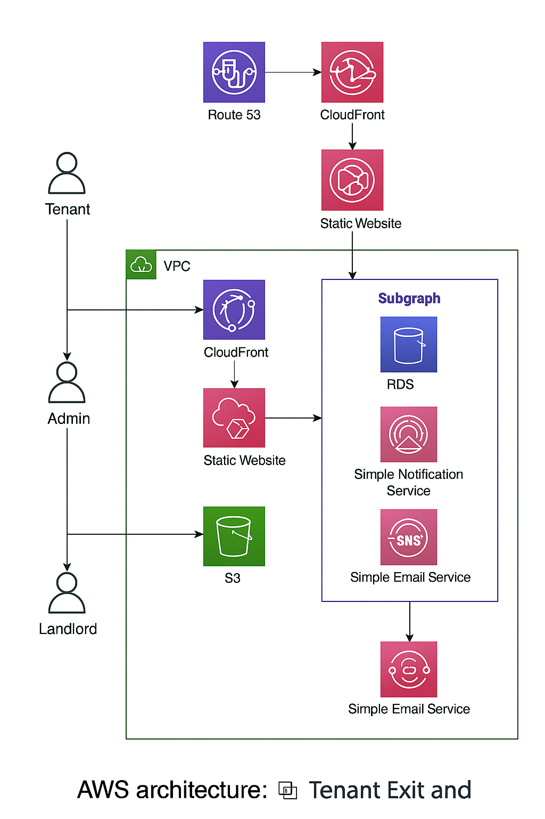

**ER(Entity -Relationship) Digram**

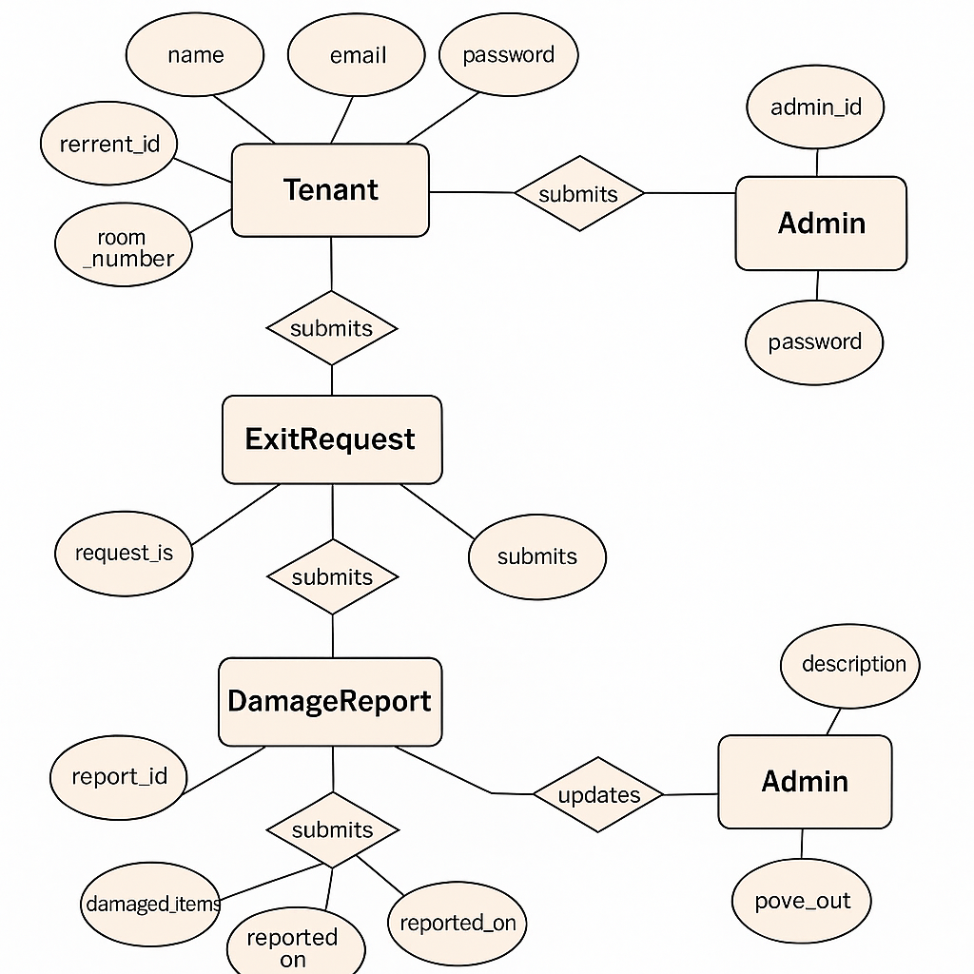

**Project structure**

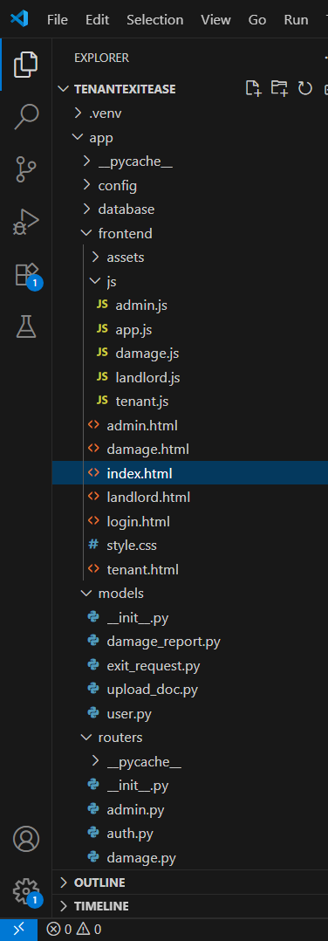 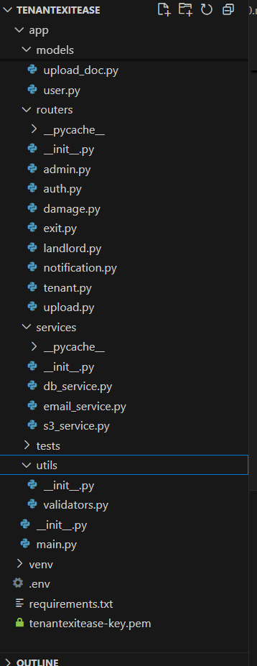

**Frontend Files**

* admin.html – Admin dashboard interface for managing tenant exit data.
* tenant.html – Tenant dashboard for submitting exit forms and viewing status.
* landlord.html – Landlord dashboard for damage reporting and confirmations.
* login.html – Login page for role-based user access.
* index.html – Entry point or landing page of the application.
* admin.js – JavaScript logic to power admin functionalities and DOM updates.
* tenant.js – JavaScript functions for tenant form submissions and feedback.
* landlord.js – Logic to capture and calculate landlord damage reports.
* damage.js – Handles fixed item selection and estimated cost calculations.
* app.js – Shared script handling login flow and basic client-side logic.
* style.css – Tailwind-based custom styling for all frontend pages.

**Backend Models**

* exit_request.py – Defines data schema for tenant exit form submissions.
* damage_report.py – Structures item-wise damage report data with pricing.
* user.py – Validates user credentials and role-based access details.
* upload_doc.py – Specifies structure for document metadata and upload records.

**API Routers**

* admin.py – Endpoints for admin to review tenant exits and reports.
* tenant.py – APIs enabling tenants to submit forms and view updates.
* landlord.py – Routes for landlords to manage property inspections.
* exit.py – Core logic for handling tenant exit process data.
* damage.py – APIs to log and fetch item-based damage reports.
* auth.py – Handles login validation and token/session setup.
* notification.py – Sends email alerts via AWS SES for key actions.
* upload.py – Routes to upload and retrieve tenant-related documents.

**Service Logic**

* db_service.py – Manages read/write operations with DynamoDB tables.
* s3_service.py – Uploads files to S3 and generates file access URLs.
* email_service.py – Sends structured email notifications through SES.

**Main Application**

* main.py – Initializes FastAPI app, registers all routers, and configures middleware.

**Pre-requisites**

* **FastAPI (Backend Framework) –** [**FastAPI Vedio Framework**](https://www.youtube.com/watch?v=0sOvCWFmrtA)
* **HTML, CSS, TailwindCSS (Frontend UI) –** [**Tailwind Installation**](https://tailwindcss.com/docs/installation)
* **Amazon Web Services (AWS) Account –** [**AWS Account Setup Doc**](https://docs.aws.amazon.com/accounts/latest/reference/manage-acct-creating.html)
* **Amazon EC2 –** [**EC2 Setup**](https://www.youtube.com/watch?v=1aXZQcG2Y6I)
* **Amazon DynamoDB –** [**DynamoDB Setup Vedio**](https://www.youtube.com/watch?v=HaEPXoXVf2k)
* **Amazon S3 & SES –** [**S3 & SES Setup vedio**](https://www.youtube.com/watch?v=XLtZcBz2Nks)
* **AWS IAM –** [**IAM Setup**](https://www.youtube.com/watch?v=KngM5bfpttA)

**Project Overflow**

**Milestone 1: AWS Environment & Account Setup**

* Launch and configure EC2 instance for backend deployment
* Generate and secure the EC2 key pair for SSH access
* Set up IAM roles and policies for service-level security
* Create and configure an S3 bucket for file/document uploads
* Configure and verify SES (Simple Email Service) and SNS (Simple Notification Service) for email alerts and notification integration

**Milestone 2: Backend Development & API Routing**

* Implement login/logout routes with session-based role access
* Develop tenant, landlord, and admin APIs (exit submission, review, status update)
* Connect FastAPI routes to DynamoDB using Boto3
* Create file upload and SES-based email trigger logic
* Integrate role-specific data views (e.g., fetch damage reports for admin)

**Milestone 3: Frontend Page Development**

* Design login, tenant, admin, and landlord pages with responsive layout
* Implement role-based JS logic for dashboard actions
* Add move-out checklist, damage report, and form upload UIs
* Display real-time data and feedback using DOM updates and alerts

**Milestone 4: Tenant Module Integration**

* Build form for exit requests with checklist, reason, and optional document upload
* Implement damage reporting UI with cost auto-calculation logic
* Enable request tracking and CSV report download via tenant panel

**Milestone 5: Landlord Dashboard Development**

* Design landlord view to fetch and display approved tenant exits
* Implement damage report submission form with itemized options
* Show room occupancy history and tenant movement timeline

**Milestone 6: Admin Panel & Review Logic**

* Build admin dashboard to view all exit requests and damage reports
* Enable real-time status updates (Approved, Rejected, InReview)
* Show all requests in organized table with action buttons

**Milestone 1: AWS Environment & Account Setup**

In this milestone, we set up the foundational AWS services required to deploy and run the TenantExitEase platform. This includes launching an EC2 instance for backend hosting, configuring a secure key pair for SSH access, and assigning IAM roles with appropriate permissions. Additionally, we created an S3 bucket for file uploads and integrated SES and SNS for email-based notifications and future alert handling.

**Activity 1.1 Launch and configure EC2 instance for backend deployment**

Steps to Set Up an AWS Account

* Visit AWS Website: Go to <https://aws.amazon.com> and click on “Create an AWS Account”.
* Enter Account Information: Provide your email address, password, and AWS account name.
* Fill in Contact Details: Choose either a personal or business account and enter required contact information.
* Add Payment Method: Enter valid debit/credit card details (for identity verification — no charges if Free Tier used).
* Verify Identity: Complete phone number verification via OTP.
* Select Support Plan: Choose Free Basic Plan (recommended for student/demo projects).
* Login to Console: After verification, access the AWS Management Console and begin using services like EC2, S3, DynamoDB, IAM, SES, and SNS.

**EC2 SETUP**

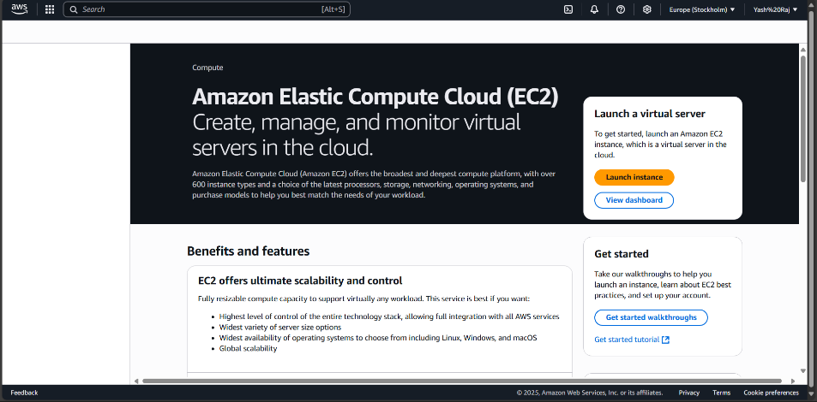

* + The Amazon EC2 Dashboard provides tools to create and manage virtual servers in the cloud.  
    Clicking “Launch Instance” begins the process of configuring a new server.  
    EC2 supports scalable, customizable infrastructure suitable for backend deployment.

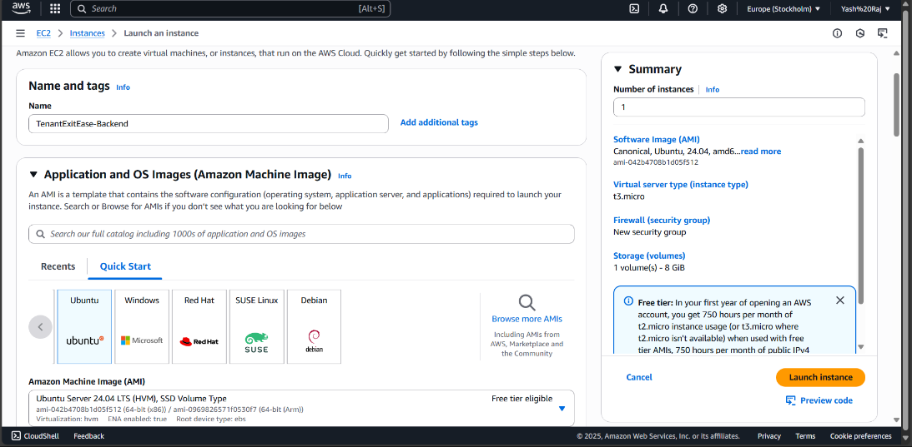

* The instance is named TenantExitEase-Backend, and an operating system is selected from the Amazon Machine Images (AMI) list.  
  Ubuntu Server 24.04 LTS is chosen for compatibility with FastAPI and Python-based deployment.  
  The setup remains within the AWS Free Tier using a t3.micro instance type.

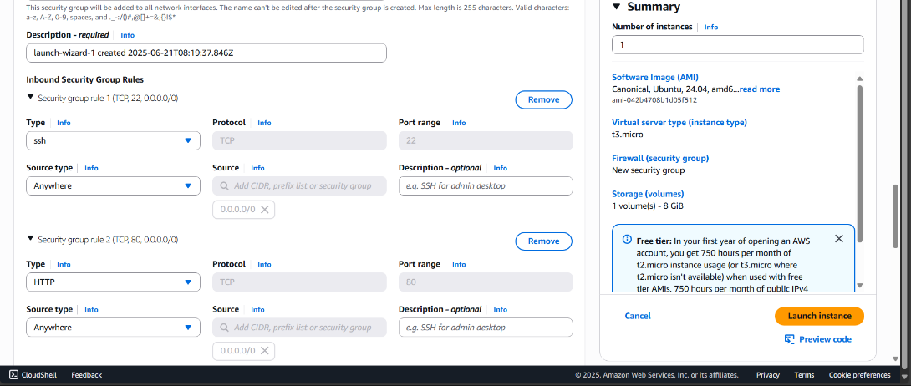

* A new security group is configured with essential inbound rules to allow external access.  
  Port 22 (SSH) is opened for secure remote terminal access, and port 80 (HTTP) is enabled for web communication.  
  The source type is set to Anywhere (0.0.0.0/0) to permit public access for development and testing purposes.

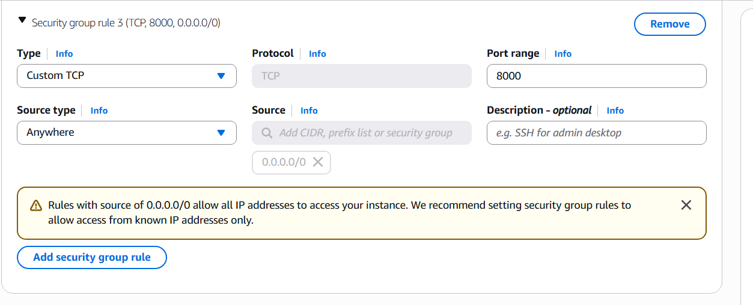

* An additional Custom TCP rule is added to open port 8000, which is the default port used by FastAPI for serving backend applications.  
  This ensures that the deployed application is publicly accessible via the browser.  
  The source remains set to Anywhere (0.0.0.0/0) to allow unrestricted access during development.

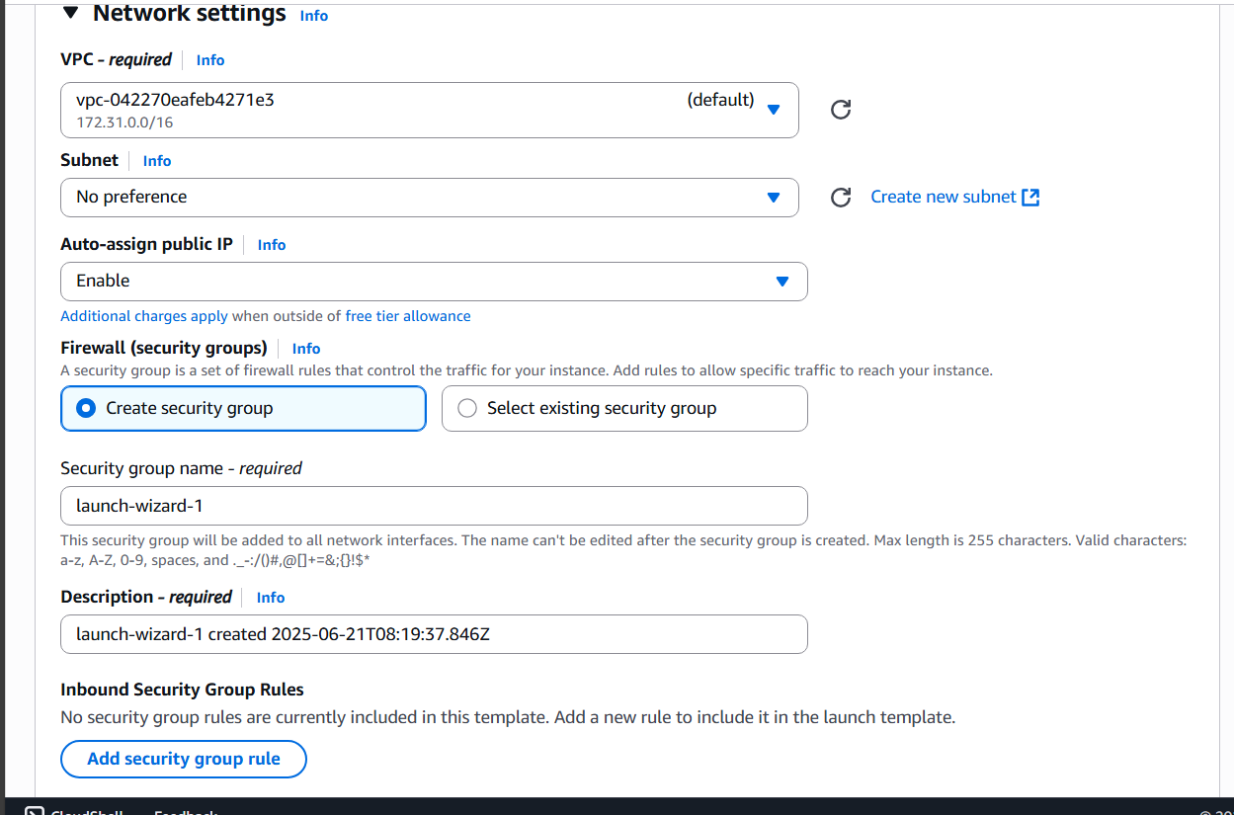

* Under the network settings, the default VPC is selected with no specific subnet preferences.  
  Auto-assign public IP is enabled to allow external access to the instance.  
  A new security group named launch-wizard-1 is created, along with a description timestamp for reference.

**Activity 1.2 Generate and secure the EC2 key pair for SSH access**

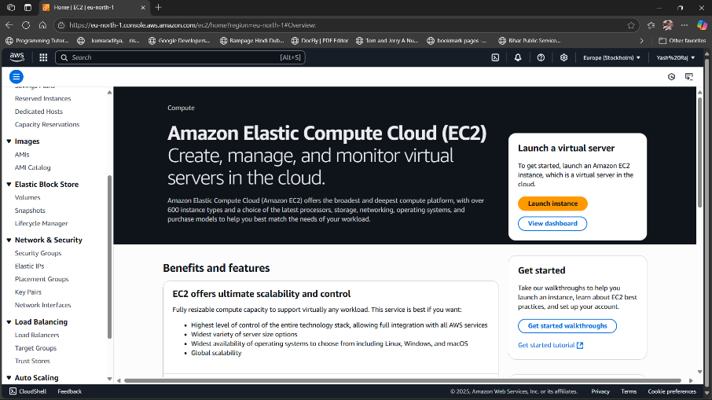

* Navigate to the Key Pairs section under EC2’s Network & Security menu.  
  This panel provides options to create and manage secure SSH credentials for EC2 instance access.

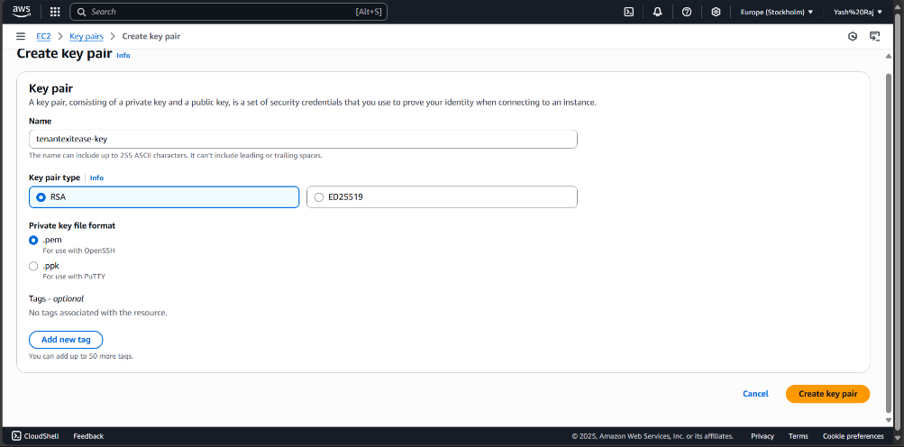

* A new key pair is configured with the name tenantexitease-key using the RSA algorithm.  
  The .pem format is selected to support SSH via OpenSSH clients.

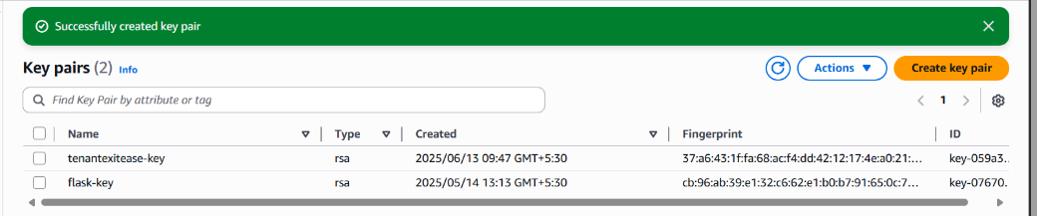

* Upon successful creation, the key pair appears in the key list.  
  It confirms the type, timestamp, and fingerprint, validating readiness for instance connection

**Activity 1.3 Set up IAM roles and policies for service-level security**

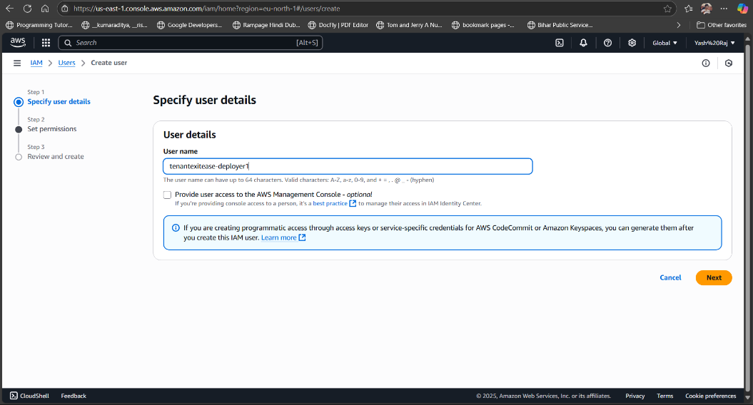

* An IAM user is created with the name tenantexitease-deployer1, intended for secure programmatic access.  
  This setup allows assigning fine-grained permissions specific to the project’s deployment needs.

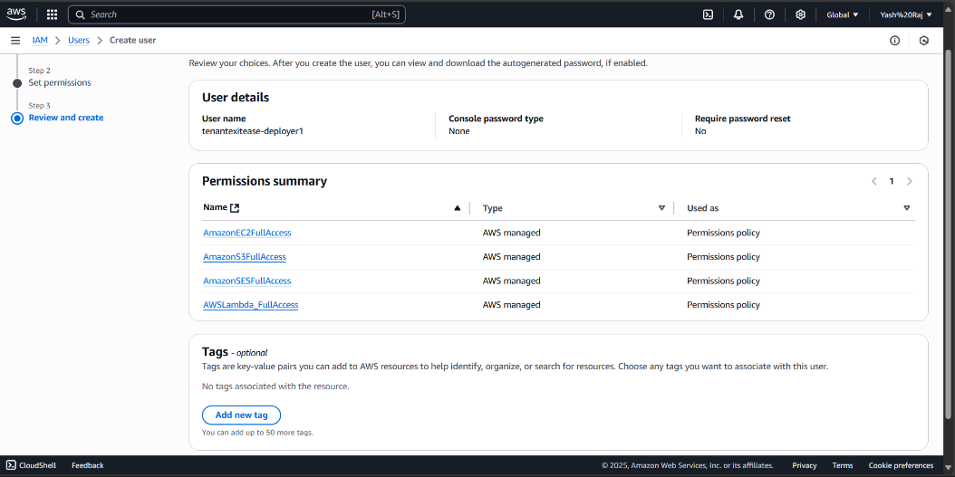

* During the permission setup, AWS managed policies such as AmazonEC2FullAccess, AmazonS3FullAccess, AmazonSESFullAccess, and AWSLambda_FullAccess are selected.  
  These grant full access to key services needed by the application.

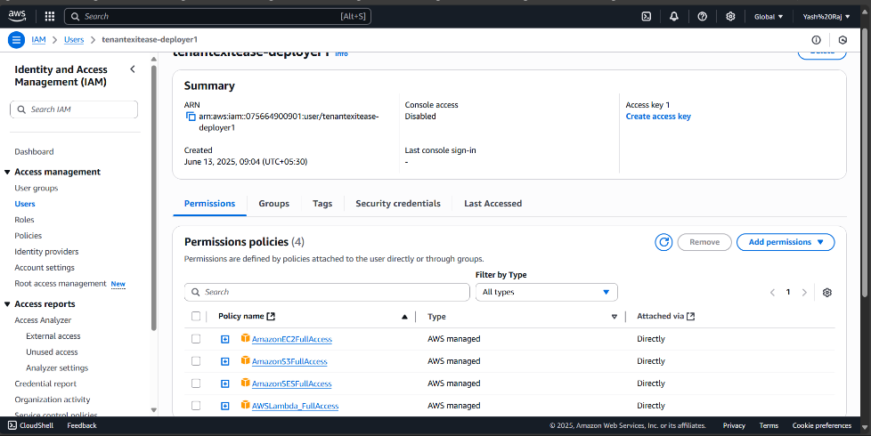

* The newly created IAM user’s summary displays assigned permission policies.  
  Each policy is attached directly, providing unrestricted access to associated AWS services.

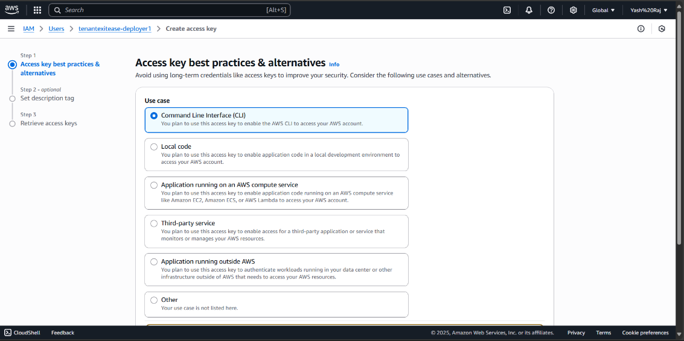

* An access key is generated for Command Line Interface (CLI) usage.  
  This allows the IAM user to interact securely with AWS services through terminal commands and scripts.

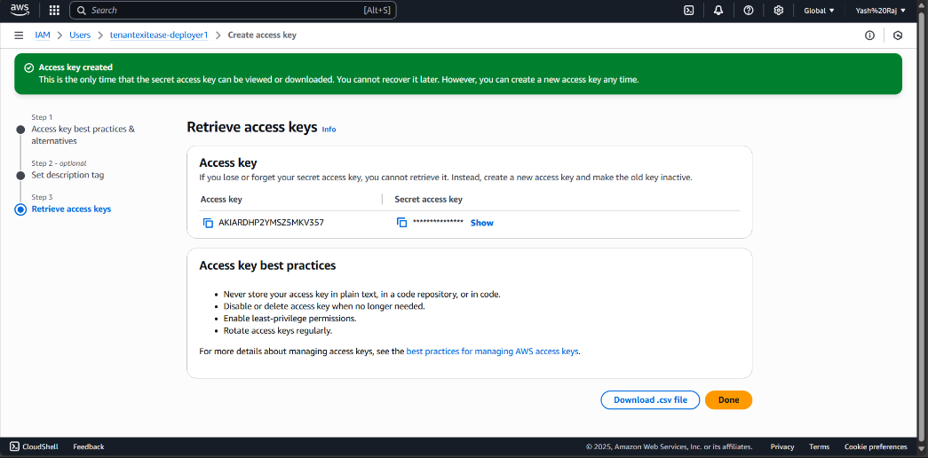

* The access key and secret key are generated and securely downloaded in .csv format.  
  Best practices are highlighted, including key rotation and avoiding plain-text storage.

**Activity 1.4 Create and configure an S3 bucket for file/document uploads**

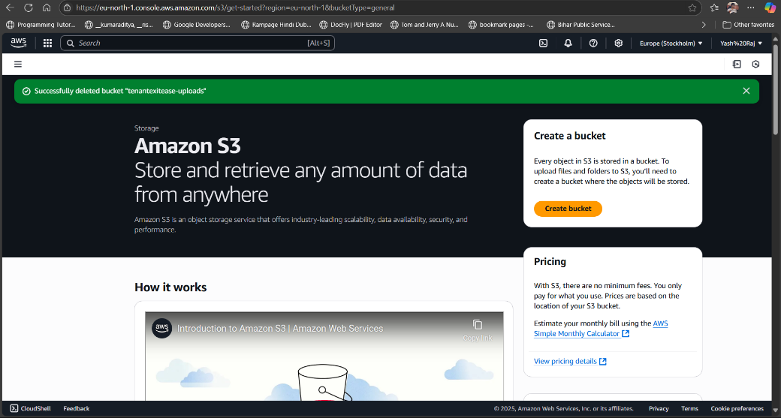 Amazon S3 is accessed from the AWS Console, which provides scalable storage for any volume of data.To begin, the “Create bucket” option is selected to initialize a new storage

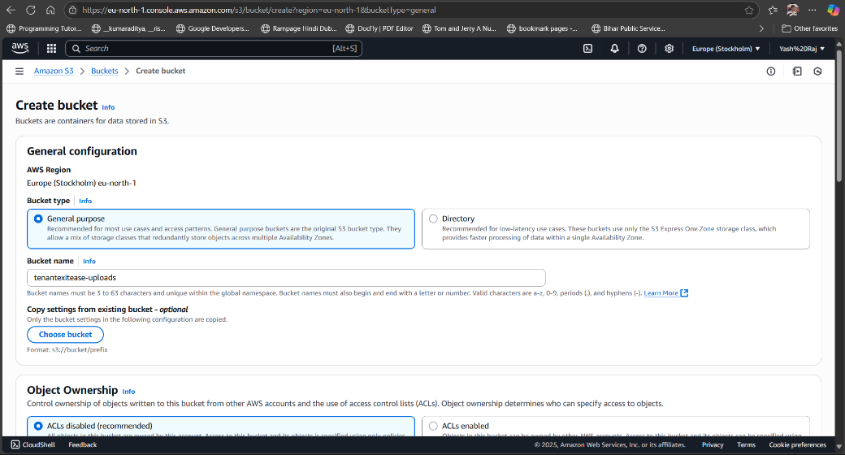

* A bucket is created with the name tenantexitease-uploads under the EU (Stockholm) region using the general-purpose type.  
  This name ensures uniqueness for uploading and storing tenant-related documents.

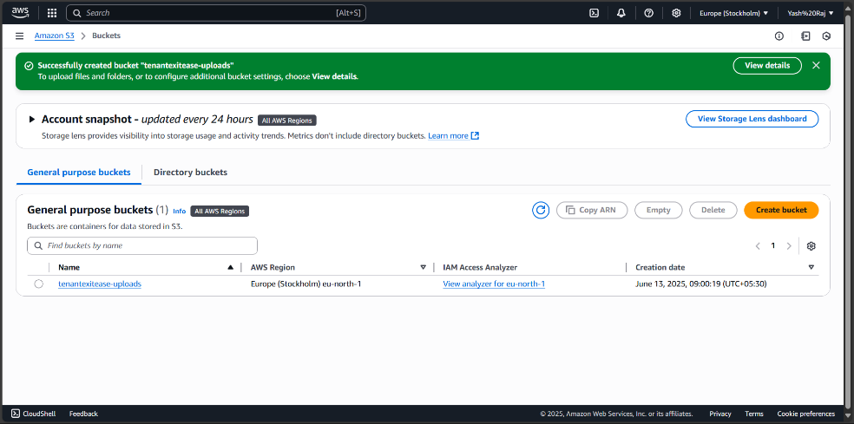

* The bucket is successfully created and now appears in the S3 dashboard, confirming readiness for use.  
  This bucket will be integrated into the application for secure file uploads.

**Activity 1.5 Configure and verify SES (Simple Email Service) and SNS (Simple Notification Service) for email alerts and notification integration**

SES Setup - Amazon SES was configured by verifying a sender email address, setting the identity type, and completing verification to enable outbound email functionality.

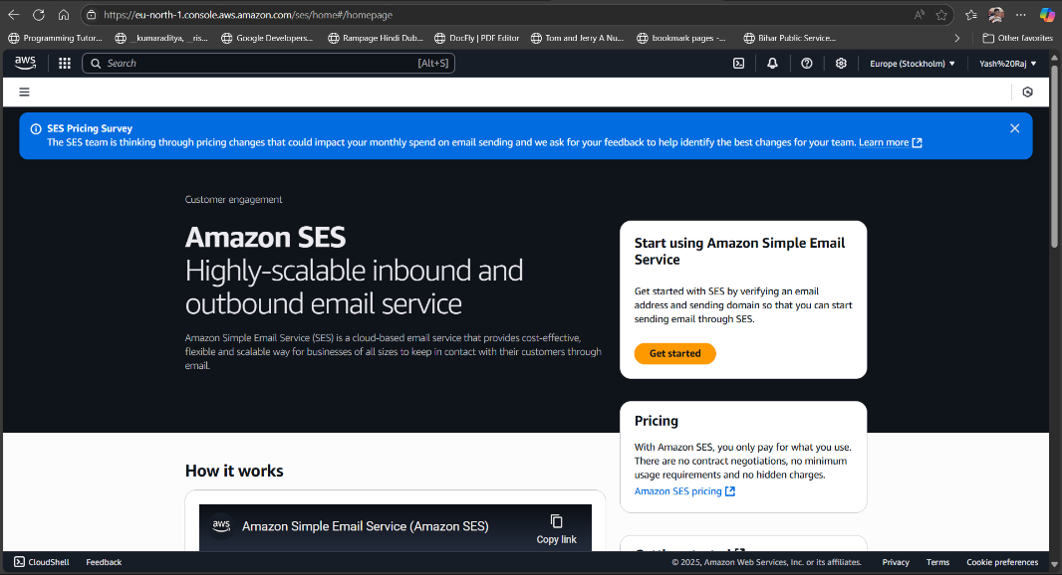

* The Amazon SES dashboard provides access to configure a scalable cloud-based email system by initiating the email identity verification process and managing sending preferences.

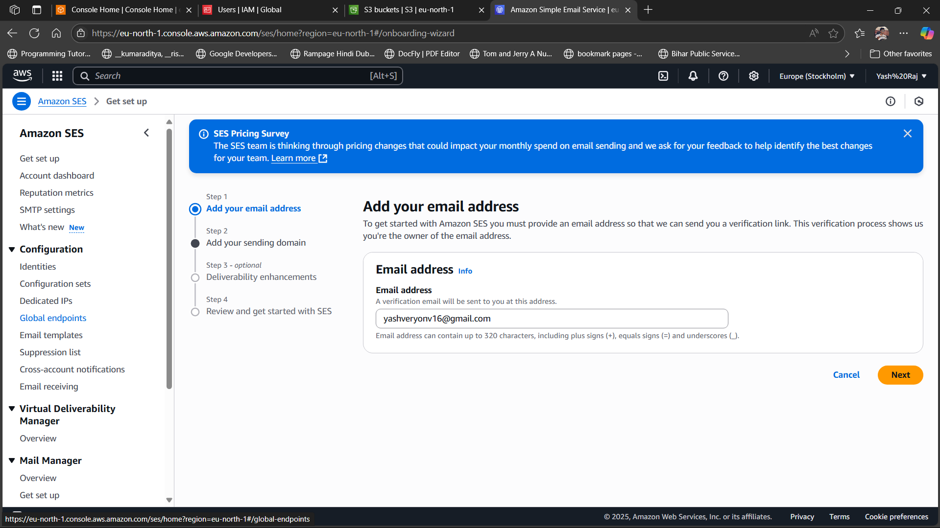

* In the Amazon SES setup process, an email address is entered and verified to enable SES to send emails on behalf of that address, ensuring authenticated communication.

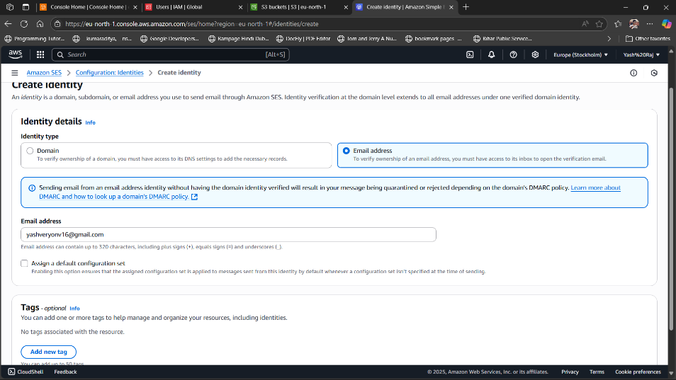

* The identity type is set to "Email address" and a specific address is entered for verification to initiate SES email sending.

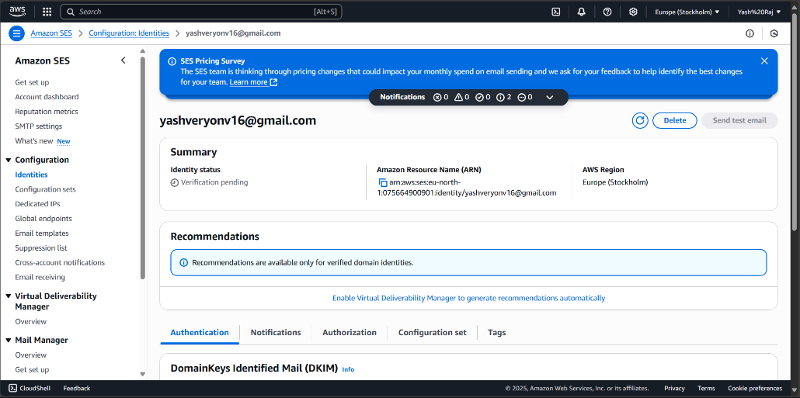

* The SES dashboard displays the entered identity with a "Verification pending" status, awaiting user confirmation via email..

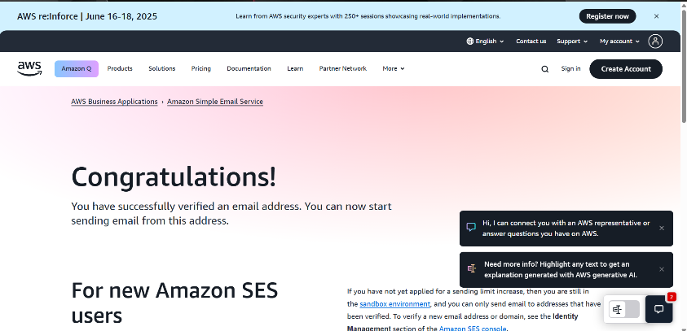

* + A confirmation screen indicates successful email verification, activating the address for sending emails through SES.

**Milestone 2: Backend Development & API Routing**

This milestone focuses on building the core backend logic using FastAPI, ensuring secure and role-based access for tenants, landlords, and admins. It includes creating RESTful APIs, integrating with DynamoDB for data storage, and adding features like file uploads and email notifications via AWS SES.

**Activity 2.1 Implement login/logout routes with session-based role access**

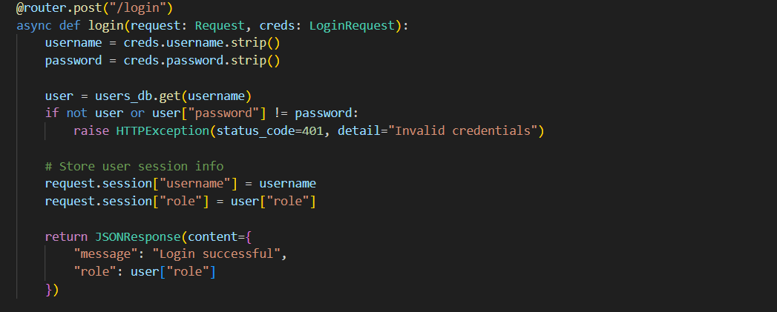

* The /login route verifies user credentials, stores session variables for username and role, and returns a login success response.

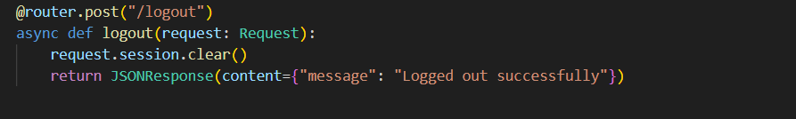

* The /logout route clears session data to securely log out the user and confirms with a success message.

**Activity 2.2 Develop tenant, landlord, and admin APIs (exit submission, review, status update)**

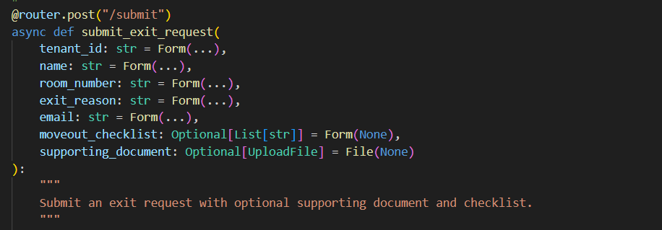

* Handles tenant exit form submissions, accepting personal details, exit reason, checklist, and optional document upload.

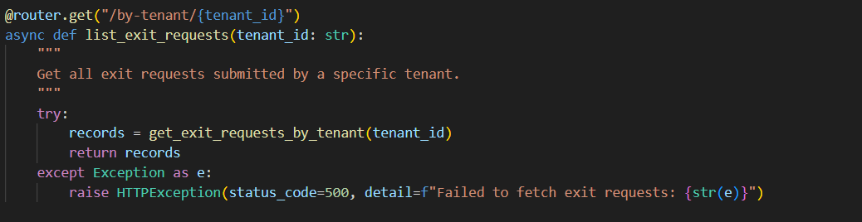

* Fetches all exit requests linked to a specific tenant ID using a secure GET request.

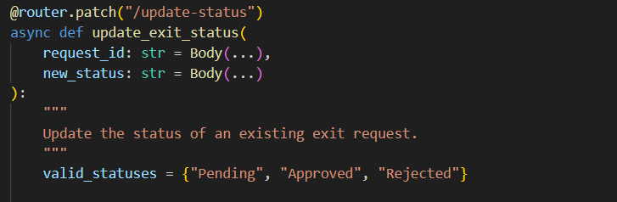

* Allows admins to update the status of submitted exit requests (e.g., Approved, Rejected).

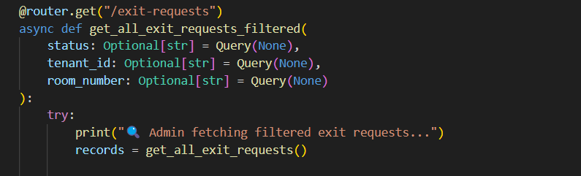

* Enables admin to filter and retrieve all exit requests by status, tenant ID, or room number.

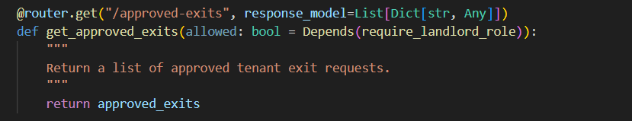

* Lets landlords access a list of all tenant exits that have been approved, with role-based restriction.

**Activity 2.3 Connect FastAPI routes to DynamoDB using Boto3**

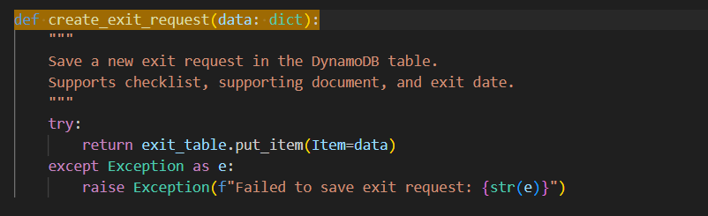

* Inserts a new exit request into DynamoDB using put_item, handling optional checklist and documents.

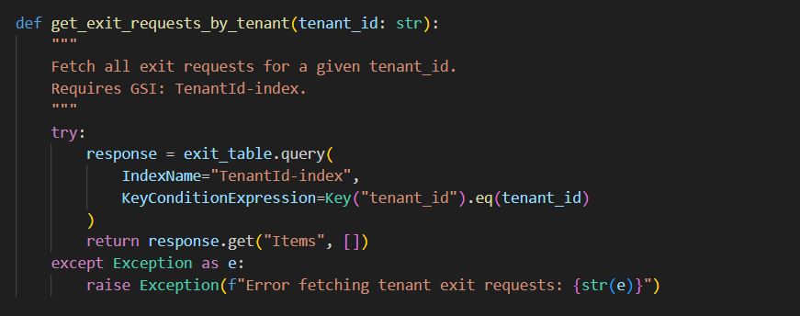

* Retrieves all exit requests submitted by a specific tenant using a GSI (TenantId-index).

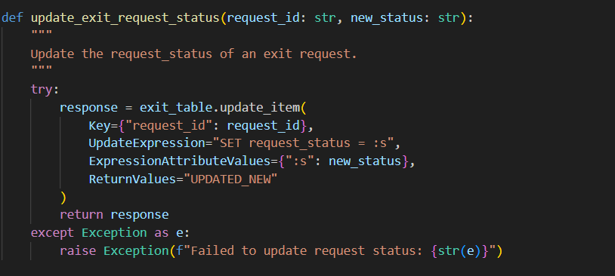

* Updates the status of an existing exit request in DynamoDB using update_item.

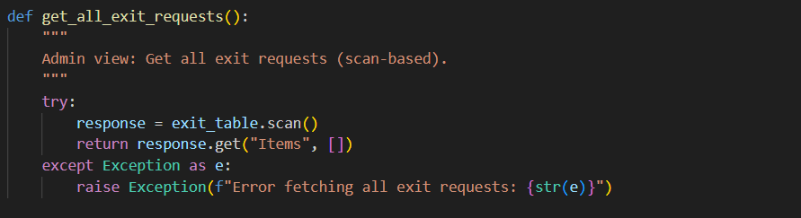

* Scans the full DynamoDB exit table to return all stored exit requests for admin viewing.

**Activity 2.4 Create file upload and SES-based email trigger logic**

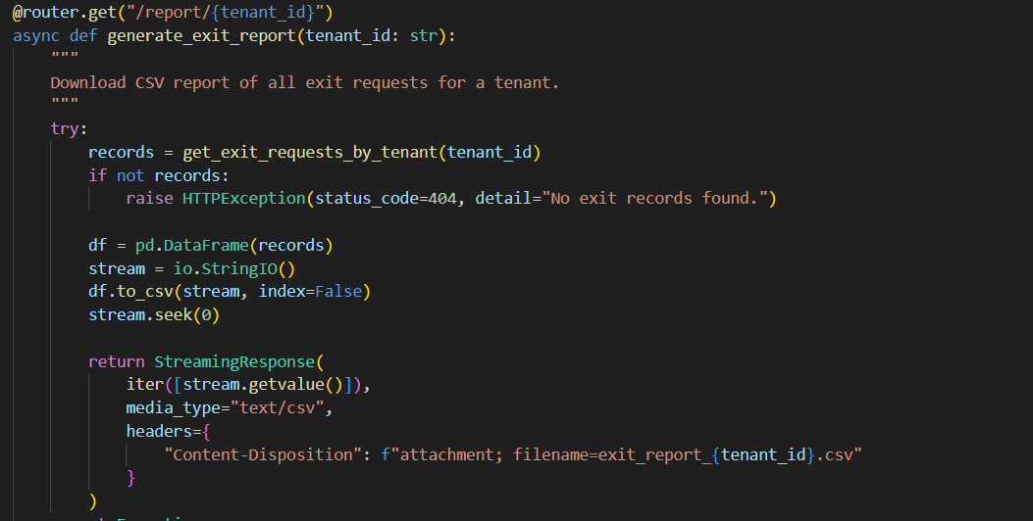

* The generate_exit_report() route creates a downloadable CSV file containing all exit requests for a tenant by converting DynamoDB data into a Pandas DataFrame.

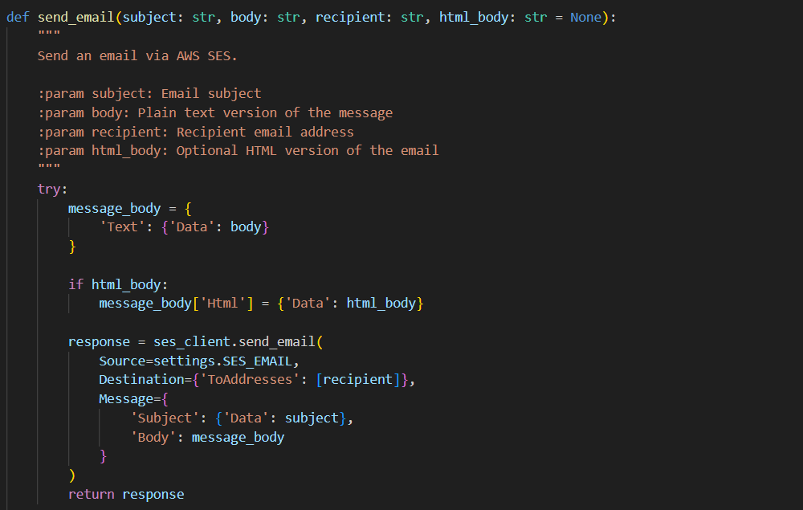

* The send_email() function uses AWS SES to send emails with optional HTML support, defining the subject, recipient, and body dynamically through the SES client.

**Activity 2.5 Integrate role-specific data views (e.g., fetch damage reports for admin)**

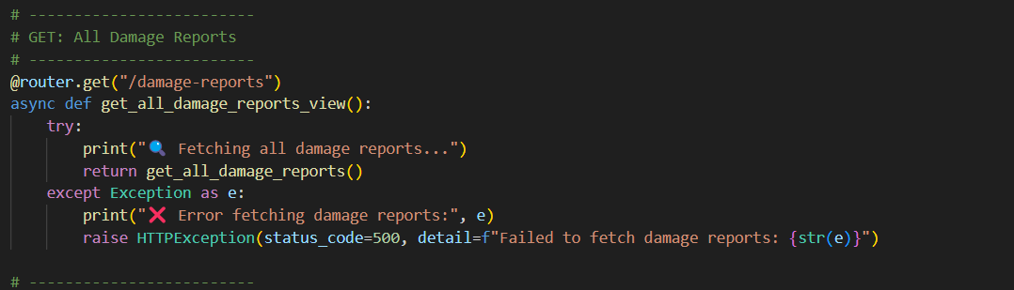

* This route get_all_damage_reports_view() in admin_routes.py enables the admin to fetch all submitted damage reports. It includes basic error handling and logs the retrieval process for debugging or monitoring purposes.

**Milestone 3: Frontend Page Development**

This milestone focuses on designing clean, responsive HTML pages for each user role—tenant, landlord, admin, and login. JavaScript files are implemented to handle role-specific dashboard actions, API calls, form submissions, and dynamic DOM updates, ensuring a smooth and interactive user experience.

**Activity 3.1 Design login, tenant, admin, and landlord pages with responsive layout**

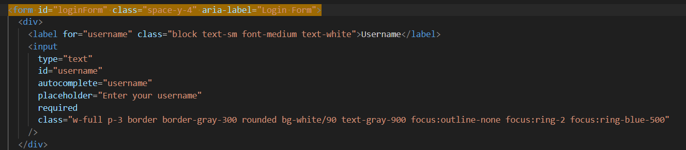

* Displays a styled login input field with validation and accessibility support, enabling user session entry.  
  The form uses Tailwind classes to ensure responsiveness and visual clarity.

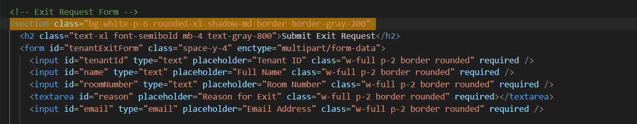

* Captures exit details using a clean layout for tenant ID, name, room, reason, and email.  
  Inputs are styled responsively with required validation and file upload support.

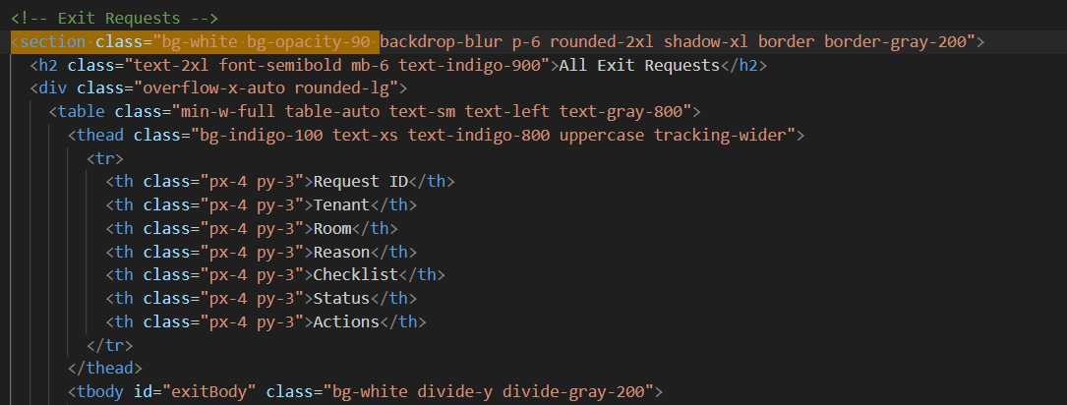

* Shows all submitted exit requests in a scrollable, styled table for admin review.  
  Uses semantic HTML and Tailwind for structure and responsive layout.

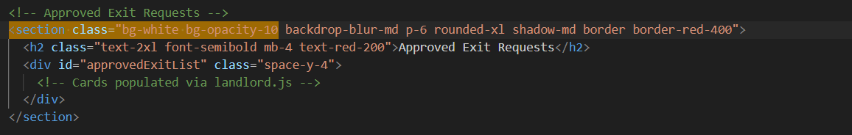

* Lists landlord-viewable approved requests in a responsive card-ready container.  
  Placeholder div #approvedExitList is dynamically populated via landlord.js.

**Activity 3.2 Implement role-based JS logic for dashboard actions**

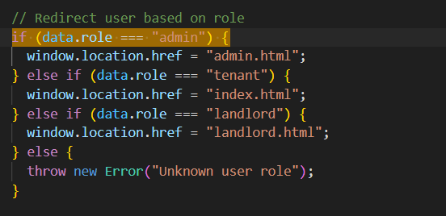

* This code handles dashboard redirection based on the logged-in user’s role—admin, tenant, or landlord—using window.location.href.

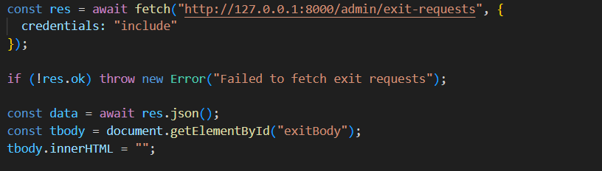

* This snippet fetches exit requests securely from the backend for admin users and dynamically injects the data into the HTML table body.

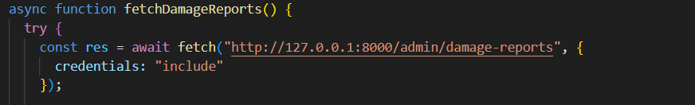

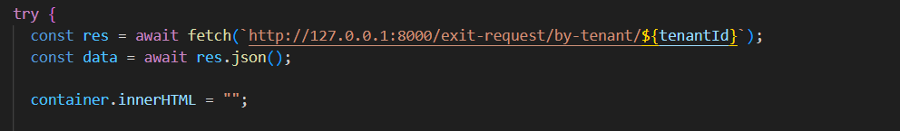

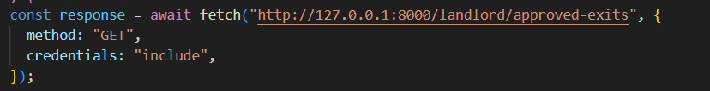

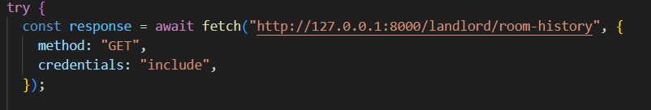

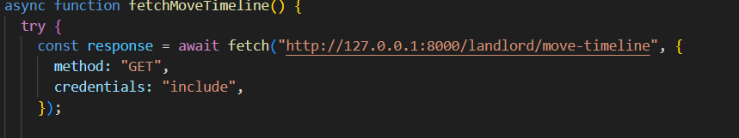

* The JavaScript logic dynamically fetches and displays role-specific data from the backend API. Admins retrieve all exit and damage reports using secure GET requests, while tenants fetch their individual exit requests via tenant ID. Landlords access filtered data such as approved exits, room history, and movement timeline through separate endpoints, enhancing dashboard interactivity based on user roles.

**Activity 3.3 Add move-out checklist, damage report, and form upload UIs**

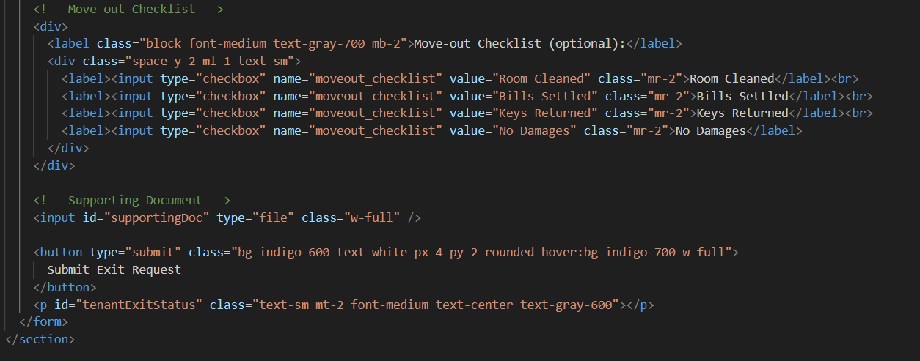

* Move-out Checklist and Supporting Document Upload (from index.html)  
  This section includes an optional move-out checklist using checkboxes for tasks like cleaning or key return, and an input field for uploading supporting documents. It enhances the tenant’s exit request form by allowing better documentation of room condition.

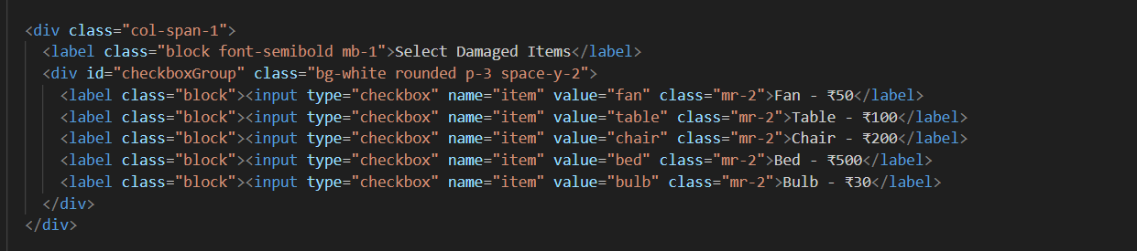

* This UI enables landlords to select damaged items using a checkbox list, each with an associated price. It supports automated damage cost calculation during exit processing.

**Activity 3.4 Display real-time data and feedback using DOM updates and alerts**

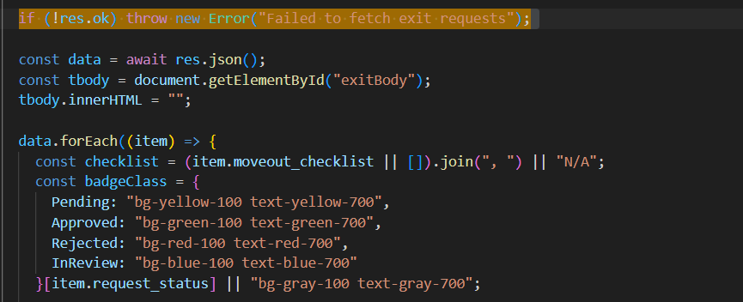

* This code dynamically builds the exit request table using data fetched from the backend and applies color-coded badges for different statuses using live DOM manipulation.

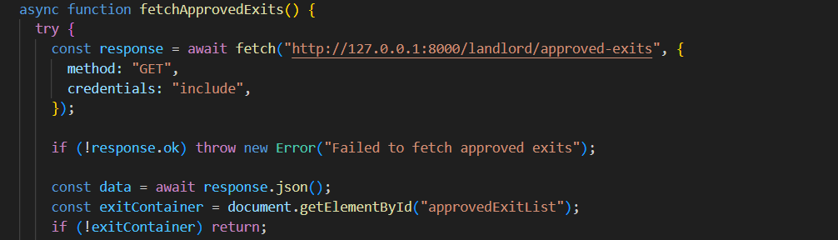

* The script fetches landlord-specific exit data and updates the approvedExitList section in real time, ensuring the UI reflects the current backend state.

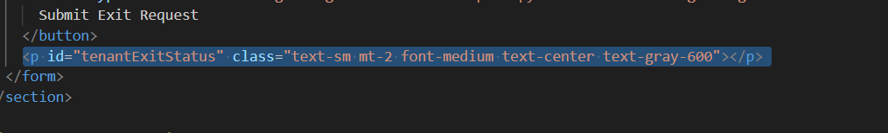

* This <p> tag with ID tenantExitStatus is updated live using JavaScript to show messages like "Submitted successfully" or "Failed", providing instant feedback to the user after form submission.

**Milestone 4: Tenant Module Integration**  
This milestone focuses on empowering tenants with key functionalities via the frontend panel. It includes submitting detailed exit requests with checklist and document uploads, reporting damages with cost auto-calculation, and tracking submitted requests along with CSV report downloads. The goal is to enhance tenant independence and streamline the exit process digitally.

**Activity 4.1 Build form for exit requests with checklist, reason, and optional document upload**

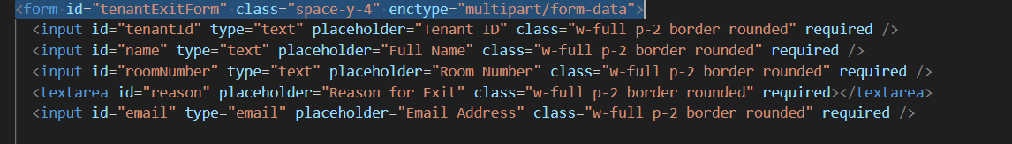

* This section defines the tenant exit request form, capturing fields such as Tenant ID, Full Name, Room Number, Reason for Exit, and Email. Each input is marked required and styled using Tailwind classes for layout consistency.

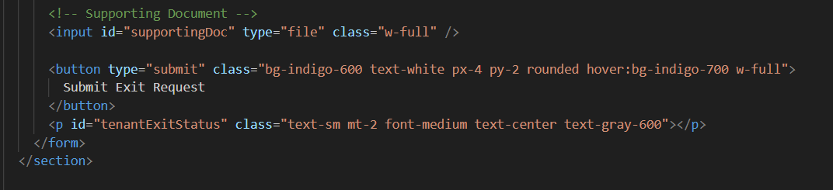

* This part adds support for uploading optional supporting documents and includes a styled submit button. A <p> tag with id="tenantExitStatus" is used to display real-time form submission feedback to the user.

**Activity 4.2 Implement damage reporting UI with cost auto-calculation logic**

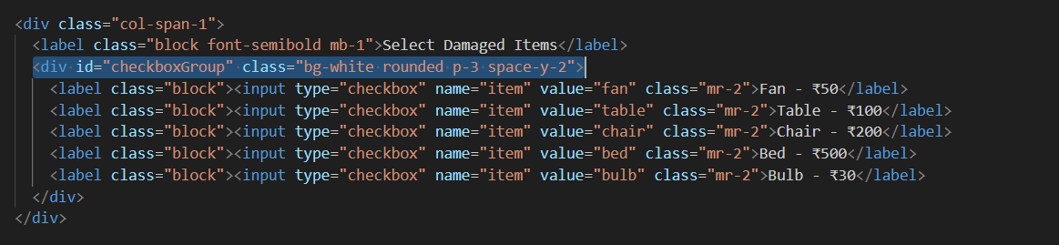

* A list of checkboxes lets landlords select damaged items such as fan, chair, or bulb; each has an associated price shown clearly next to the label.

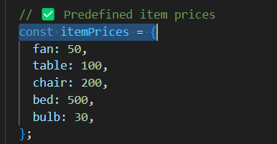

* A JavaScript object defines fixed prices for each item, enabling automatic total calculation based on checkbox selections.

**Activity 4.3 Enable request tracking and CSV report download via tenant panel**

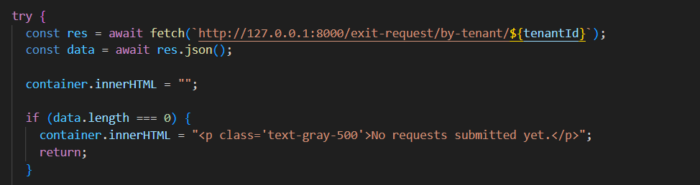

* The code fetches exit requests for a specific tenant using their tenant ID and displays a message if no requests are found.

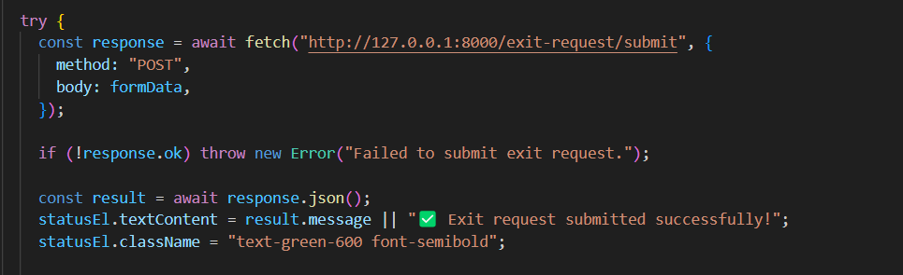

* This logic handles the submission of an exit request, displaying a success message upon completion or an error if the API fails.

**Milestone 5: Landlord Dashboard Development**

This milestone centers on building a comprehensive interface for landlords to monitor tenant activities. It includes displaying approved exit requests, submitting damage reports with predefined item options, and viewing historical room occupancy and movement timeline. The objective is to provide clarity and control to landlords during tenant transitions.

**Activity 5.1 Design landlord view to fetch and display approved tenant exits**

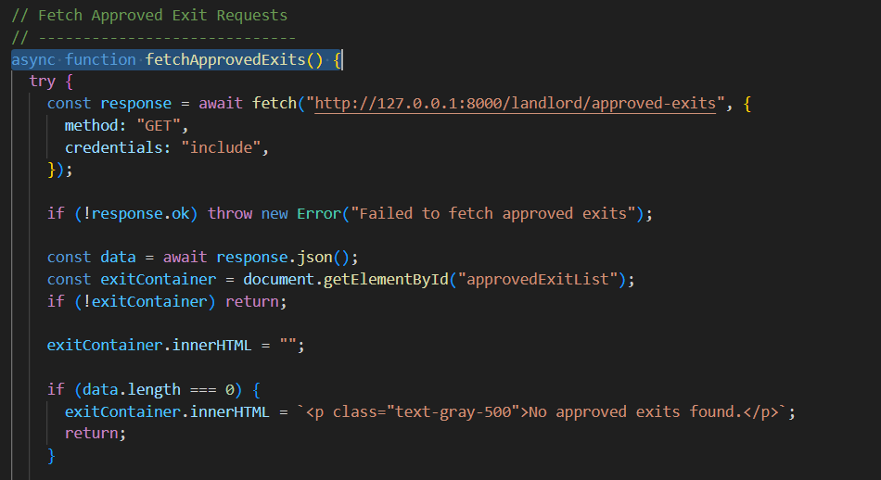

* This function fetches approved tenant exit requests from the backend and dynamically populates the approvedExitList container on the landlord dashboard. It ensures feedback is shown if no data is found.

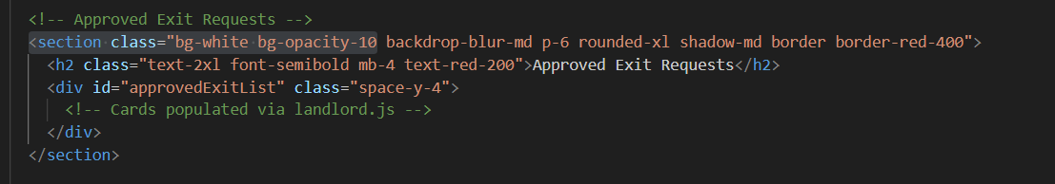

* This section holds the container (approvedExitList) where approved exit request cards are rendered. It's styled with Tailwind classes for clear visibility on the landlord page.

**Activity 5.2 Implement damage report submission form with itemized options**

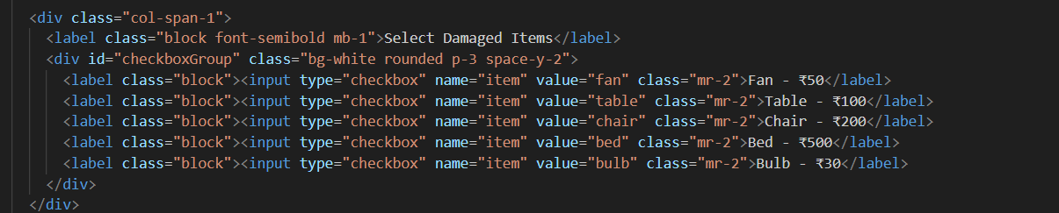

* A checklist UI allows landlords to select damaged items like fan, table, bed, etc., each labeled with its predefined cost.

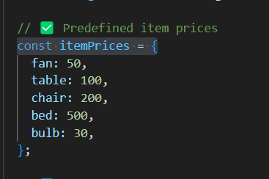

* A JS object named itemPrices defines static values for each item, enabling automatic total calculation based on selections.

**Activity 5.3 Show room occupancy history and tenant movement timeline**

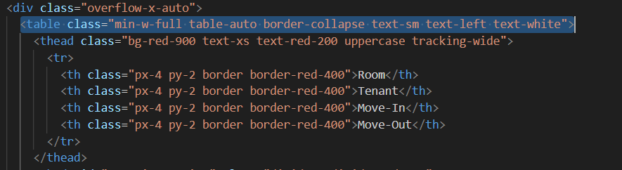

* This HTML snippet defines a responsive table using TailwindCSS, styled with red borders and white text. The table header displays columns for Room, Tenant, Move-In, and Move-Out dates.

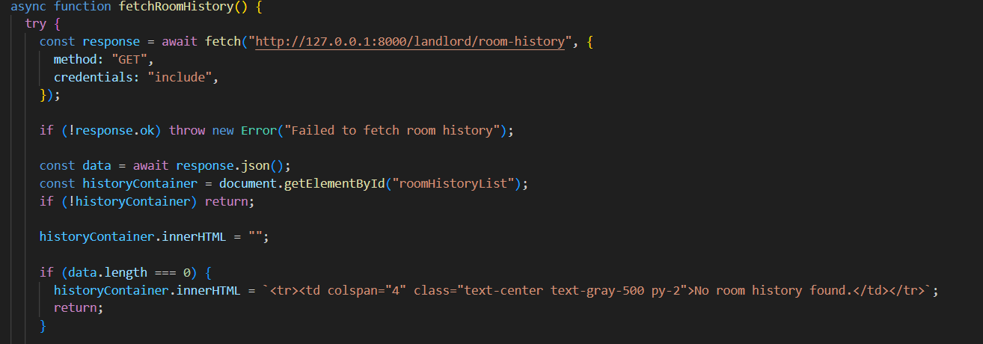

* This function (fetchRoomHistory) fetches historical room occupancy data using a GET request to /landlord/room-history. It updates the HTML DOM to display data in the roomHistoryList container or shows a fallback message if no data is found.

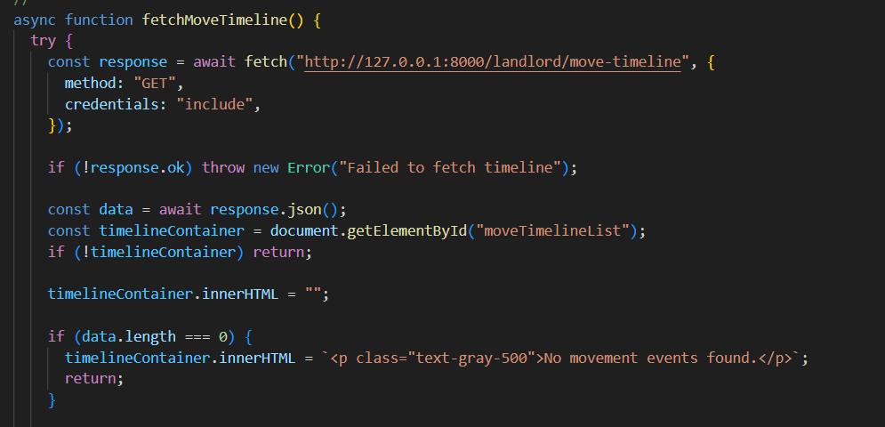

* The fetchMoveTimeline function retrieves tenant movement logs from /landlord/move-timeline. It populates the moveTimelineList div with records or displays a message when no timeline entries are found.

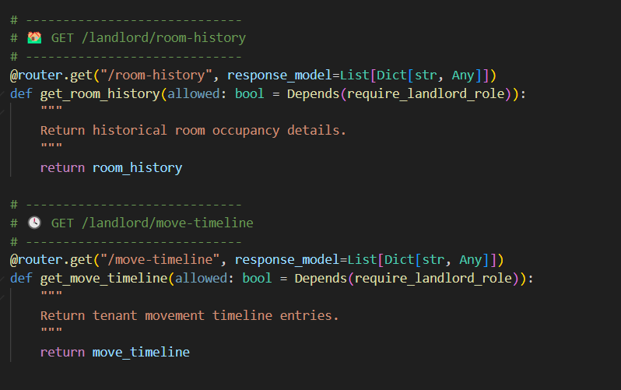

* The FastAPI endpoints /room-history and /move-timeline are defined to return room occupancy and tenant movement history respectively. These routes are protected using the require_landlord_role dependency to ensure only landlords can access them.

**Milestone 6: Admin Panel & Review Logic**

This milestone focuses on building a functional admin dashboard to oversee all exit and damage reports. It enables the admin to perform real-time status updates and view requests in a clean, actionable tabular format. The goal is to centralize review operations for efficient decision-making.

**Activity 6.1 Build admin dashboard to view all exit requests and damage reports**

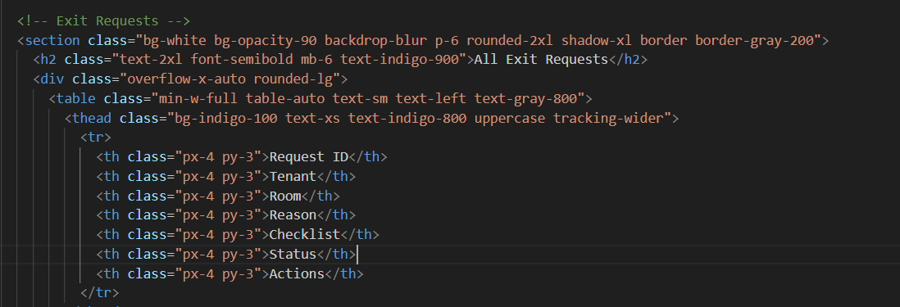

* The admin panel interface includes a responsive table to display tenant exit request data with headings like tenant name, room, reason, checklist, and status.

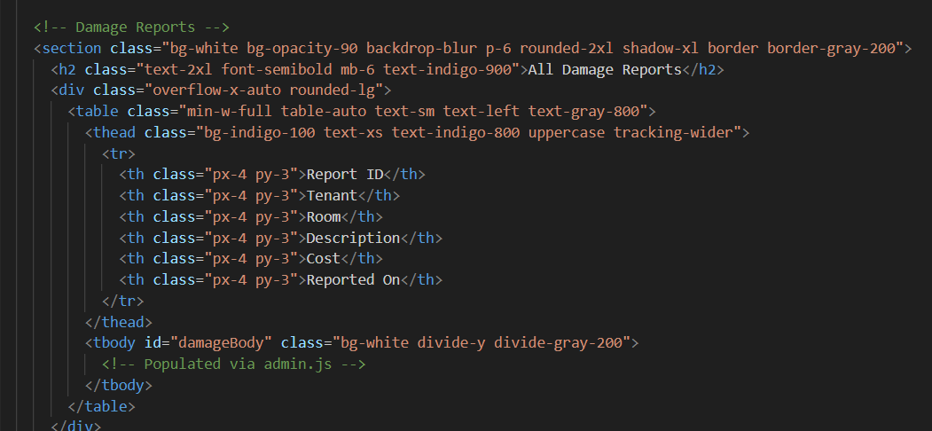

* This section structures the layout for viewing all submitted damage reports, showing cost, description, and date in a clean table format.

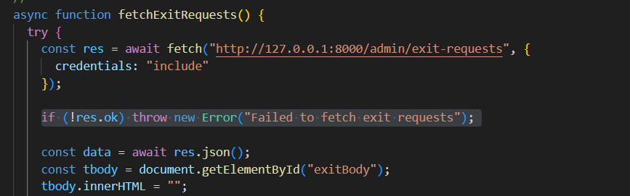

* JavaScript function fetchExitRequests() retrieves exit data from the backend API and populates the exitBody of the admin table dynamically using DOM manipulation.

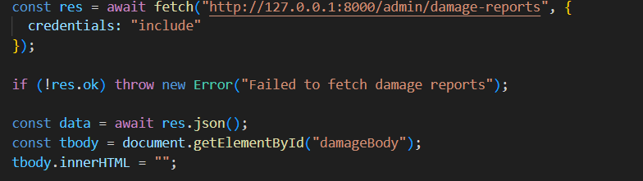

* This script pulls all damage report entries from the FastAPI backend and displays them in the designated damageBody section of the admin dashboard.

**Activity 6.2 Enable real-time status updates (Approved, Rejected, InReview)**

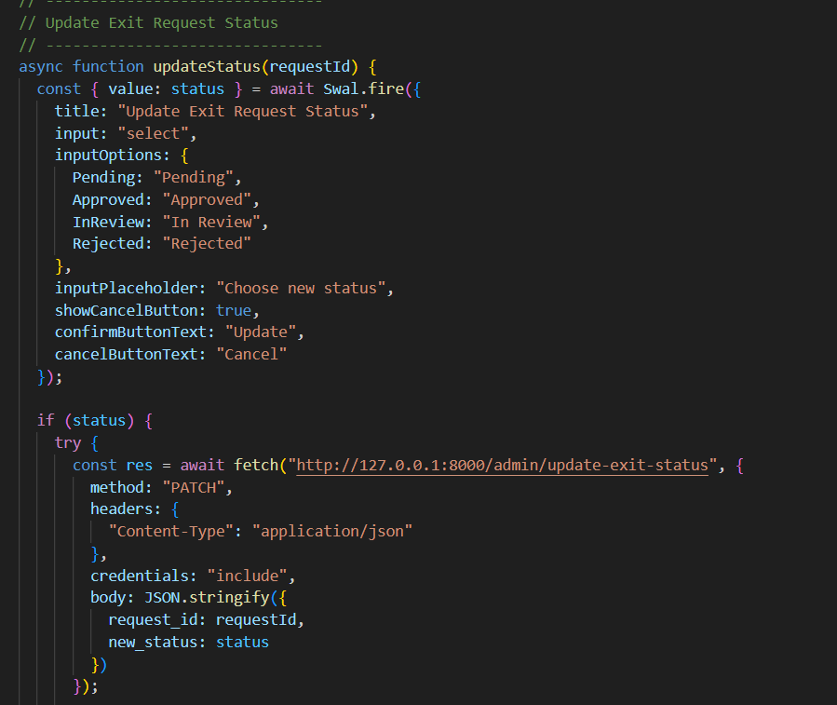

* This JavaScript function displays a SweetAlert dropdown to let the admin select a new status for an exit request.  
  If confirmed, it sends a PATCH request to /admin/update-exit-status with the selected status.  
  It enables real-time updates of exit statuses directly from the admin panel UI.

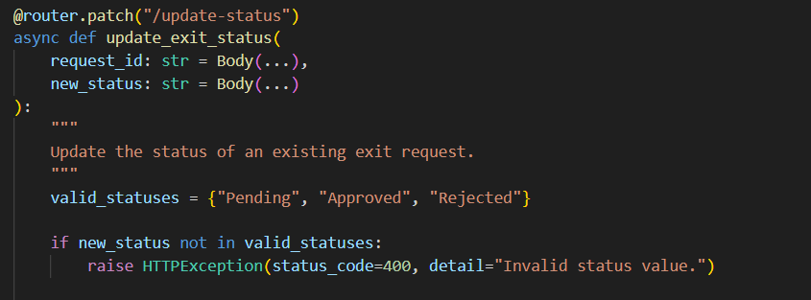

* This FastAPI route handles updating the exit request status in the backend via a PATCH method.  
  It validates the new status (Pending, Approved, or Rejected) and updates the record in DynamoDB.  
  If an invalid status is provided, it raises an HTTP 400 error to prevent misuse.

**Activity 6.3 Show all requests in organized table with action buttons**

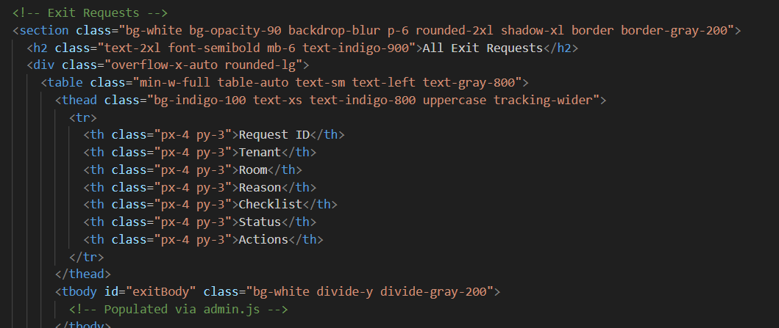

* This HTML section defines a well-structured table inside admin.html for listing all tenant exit requests. It includes columns for Request ID, Tenant, Room, Reason, Checklist, Status, and Actions. The <tbody> with ID exitBody is meant to be dynamically populated using JavaScript.

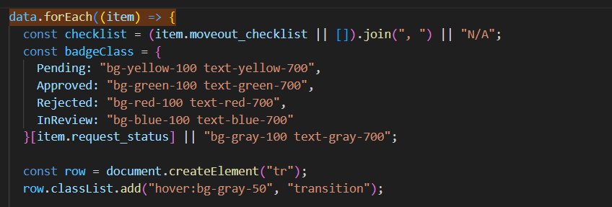

* In admin.js, the data.forEach() function iterates over fetched exit request data. For each item, it builds a table row (<tr>) dynamically, applies styling based on status, and inserts move-out checklist and other fields into the table. This logic connects directly to the exitBody table from the HTML.

**Project Output**

**Login Dashboard**

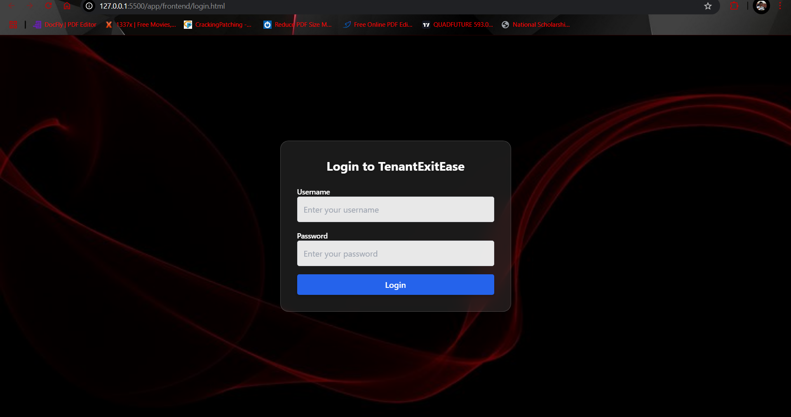

The login page of **TenantExitEase** features a sleek, dark-themed interface with a glowing red abstract background. Centered on the screen is a modern, rounded login form for users to enter their **username and password**, followed by a clear blue **Login** button. The minimalist design ensures focus and ease of access for all user roles.

**Admin DashBoard**

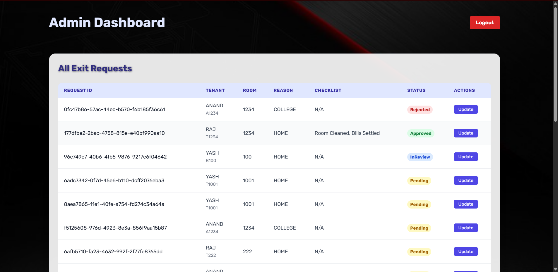

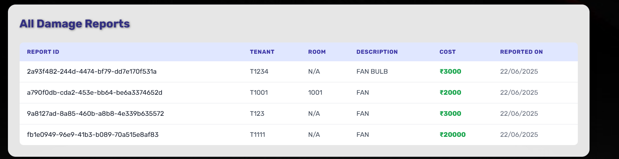

The **Admin Dashboard** provides a centralized view for managing tenant exit requests and damage reports. The first section showcases a styled table displaying all exit requests, including key details like request ID, tenant info, checklist, status badges, and an action button for updating status in real time. The second section presents all submitted **damage reports**, showing report IDs, items reported, cost (auto-calculated and styled in green), and date of submission—ensuring streamlined review and record-keeping for the admin.

**Landlord DashBoard**

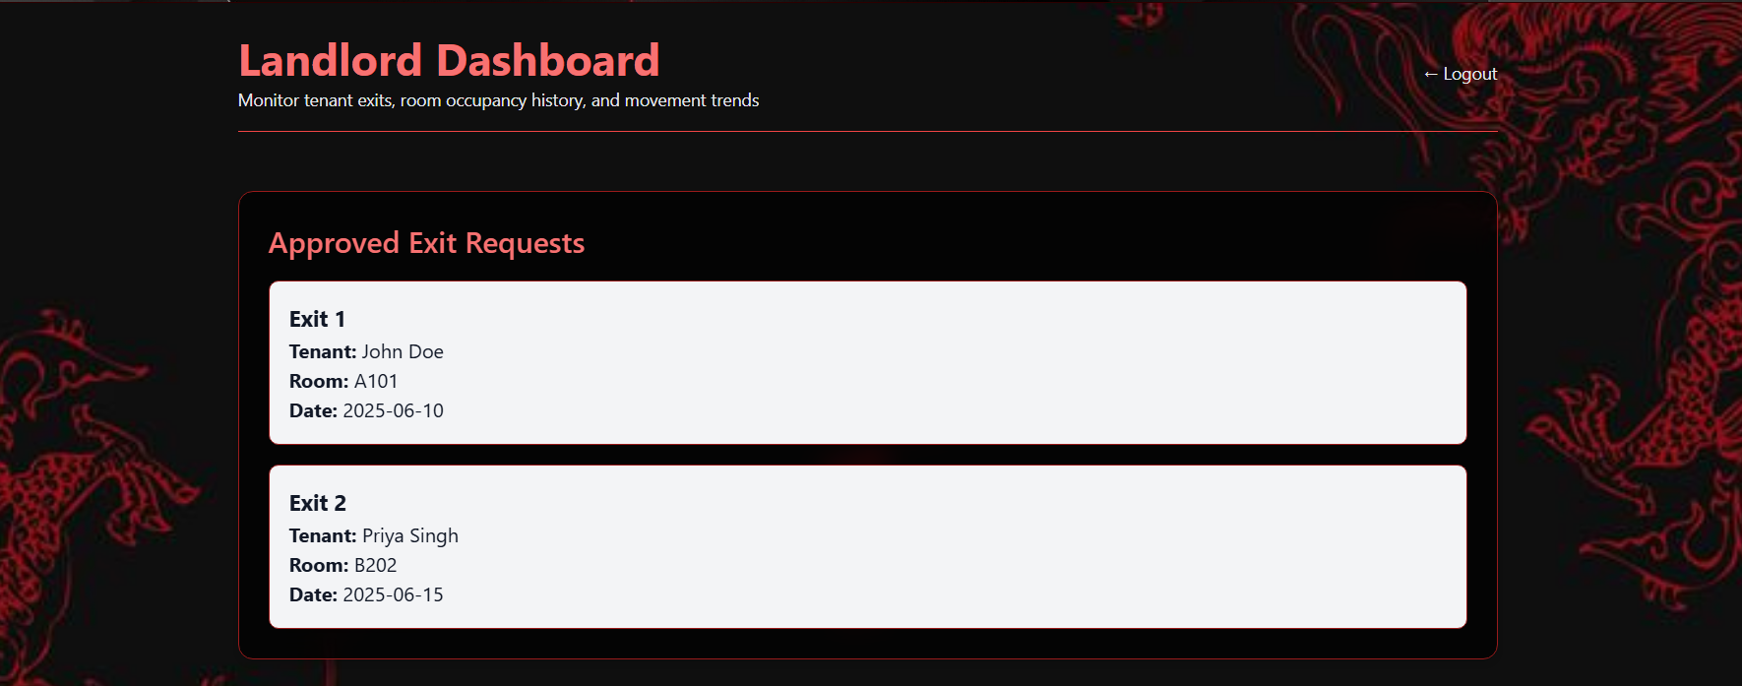

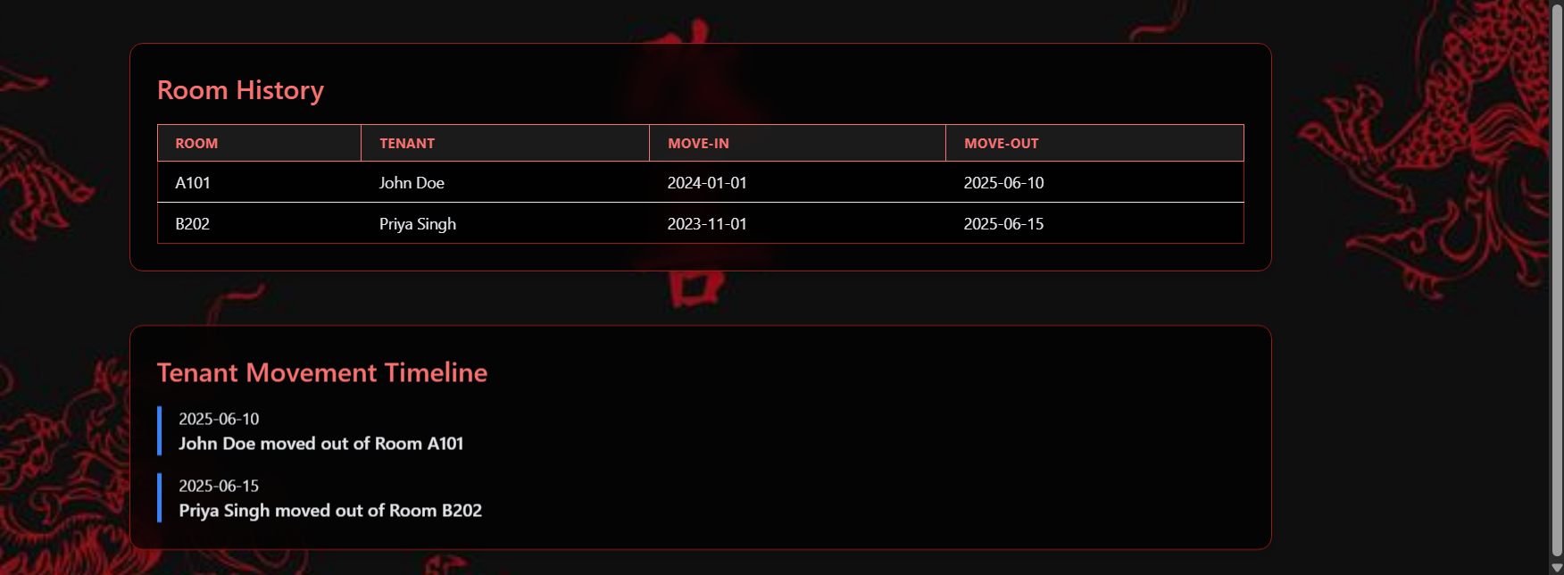

The landlord dashboard offers a clean red-and-black themed layout displaying real-time approved exit requests, complete with tenant name, room number, and exit date. It also presents a **Room History** table showcasing past occupancy details and a **Tenant Movement Timeline** with visually appealing date-stamped entries. The dashboard is dynamically updated using JavaScript to fetch backend data and display it in an organized format tailored to the landlord’s role.

**Tenant DashBoard**

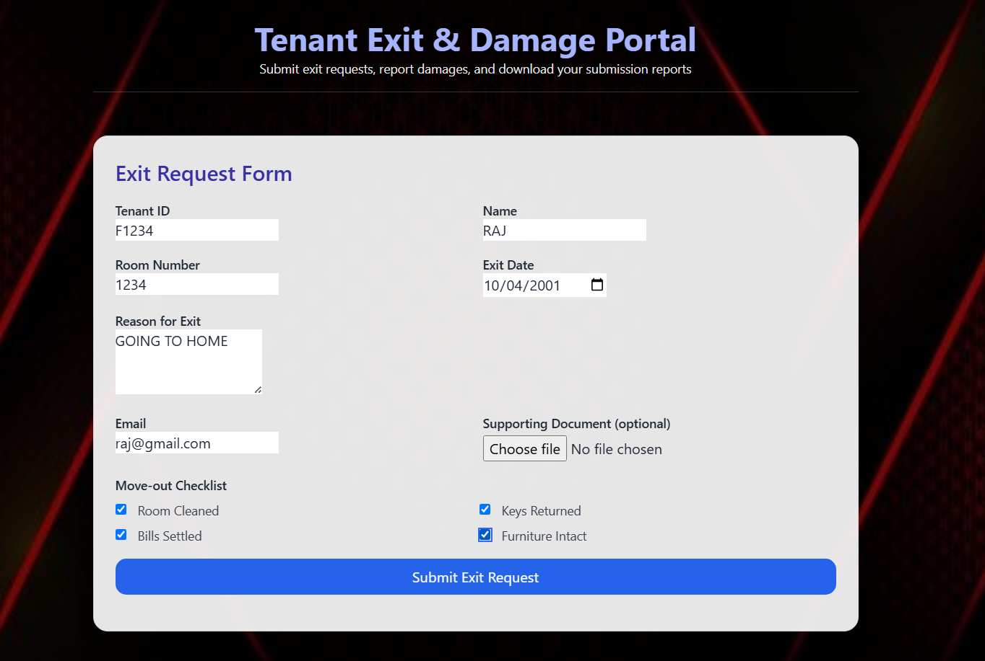

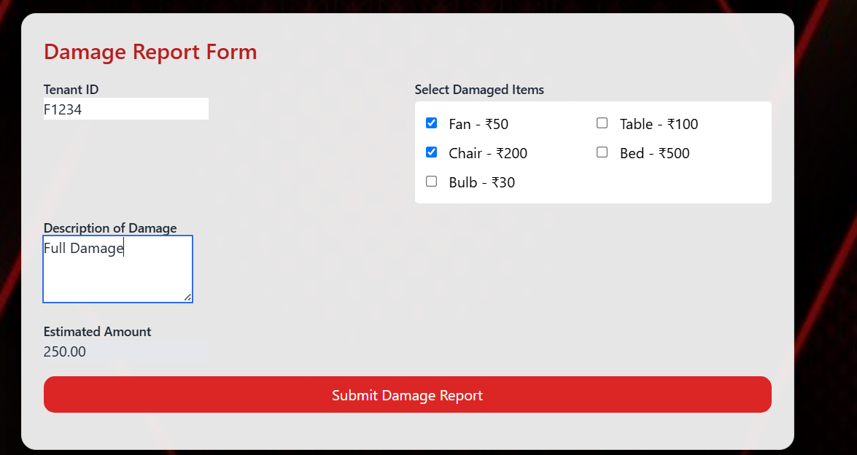

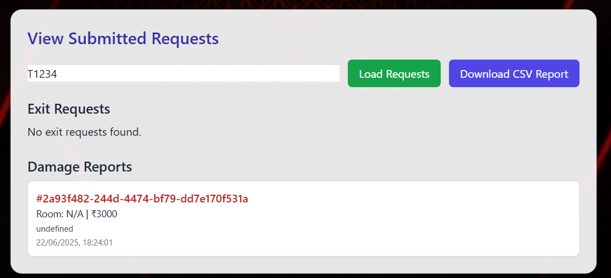

The Tenant Dashboard offers a seamless interface for submitting exit requests, reporting damages, and tracking submission history. The **Exit Request Form** allows tenants to provide personal details, reasons for exit, and attach optional documents with checklist options. The **Damage Report Form** supports itemized damage selection with automatic cost calculation for transparent reporting. In the **submission tracking panel**, tenants can view their previously submitted exit requests and damage reports and also download a CSV report of their records instantly.

**Logout Button**

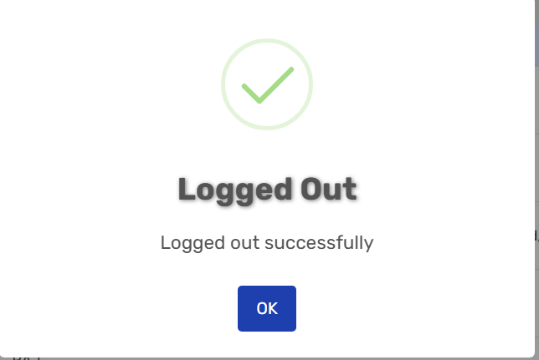

The logout success alert confirms the user has been securely logged out of the system. A clean modal with a green checkmark and confirmation message enhances the user experience and feedback clarity.

**Conclusion**

The *TenantExitEase* project marks the successful implementation of a role-based tenant exit and damage reporting system deployed over a FastAPI backend with a visually responsive and interactive frontend. Designed for smooth property management operations, this solution streamlines exit workflows for tenants, landlords, and administrators while leveraging AWS capabilities and modern JavaScript logic. The application not only centralizes exit and damage documentation but also simplifies communication, reporting, and transparency.

**Project Achievements**

* Role-Based Access: Integrated distinct login views and dashboards for *admin*, *tenant*, and *landlord* with session handling and redirection logic.
* Exit Request Module: Developed a clean and responsive form capturing tenant exit details, checklists, and optional document uploads.
* File Upload + SES Alerts: Enabled support for document upload and SES-based notification triggers for admins on submission.
* Damage Reporting: Designed an interactive damage report form with predefined items and real-time cost calculation logic.
* Admin Dashboard: Admins can view all exit requests and damage reports in dynamic tables with real-time action buttons to approve, reject, or mark in review.
* Landlord Dashboard: Landlords can monitor approved exits, room history, and movement timelines in a visually thematic layout.
* Request Tracker + CSV Export: Tenants can track their submissions and download CSV reports for documentation.

**Challenges Faced**

* Session Management: Implementing consistent session handling across roles using FastAPI cookies and ensuring secure redirects.
* Role-Based View Restriction: Properly blocking unauthorized users from accessing dashboards via backend role checks and frontend guards.
* File Upload Compatibility: Ensuring the uploaded documents were sent via multipart/form-data and validated properly before storage.
* Live DOM Manipulation: Managing complex DOM updates across different roles and ensuring tables updated dynamically without reloading.
* Status Update Logic: Designing the admin action button system with support for real-time PATCH requests and updating backend states accordingly.
* UI Synchronization: Keeping UI consistent across all roles with varied color themes (black/red, white/indigo) and ensuring responsiveness.

**Learning Outcomes**

* Understood the integration of FastAPI backend with JavaScript-based dynamic frontend for real-time data interactions.
* Learned to design dashboards role-wise with secure access and session tracking logic.
* Gained experience in file uploads, email service integration (AWS SES), and API route structuring.
* Explored real-world use of DOM manipulation, alert modals (SweetAlert2), and visual theming using CSS frameworks.
* Developed skills in debugging API calls, handling edge cases (empty data, bad requests), and maintaining state on the frontend.

**Future Scope**

* **Cloud Deployment**: Full deployment on AWS EC2, RDS/DynamoDB, and S3 with IAM-based access control for production.
* **Analytics Dashboard**: Add visual graphs showing exit request trends, peak periods, and damage cost breakdowns for admins.
* **Notification Enhancements**: Use AWS SNS or WebSocket-based notifications for real-time alerts.
* **Mobile View Optimization**: Improve mobile responsiveness with tailored layouts and PWA support.
* **Invoice Generation**: Auto-generate PDFs for final settlement and mail them to tenants upon approval.
* **OAuth Login**: Integrate Google or email/password-based authentication for better scalability.

This project reflects a successful blend of backend engineering and frontend design that tackles a real-world problem while enhancing software development and project planning skills.